Tribhuvan University
Institute of Science and Technology



A Dissertation Proposal on
“Comparative Benchmarking of CatBoost, TabPFN, and TabFM for Explainable Multi-Tier Hair Fall Risk Stratification”

Supervised by
Asst. Prof. Jagadish Bhatta

Submitted by
Nirajan Shahi
Roll no. 49/079

Submitted to
Central Department of Computer Science and Information Technology
Tribhuvan University, Kirtipur
Kathmandu, Nepal

In partial fulfillment of the requirement for Master’s Degree in Computer Science and Information technology (M.Sc. CSIT)
Table of Contents

Table of Contents i
List of Figures ii
List of Tables iii
List of Abbreviation iv
Chapter 1: Introduction 1
1.1 Overview 1
1.2 Problem Statement 2
1.3 Objective 3
Chapter 2: Background Study and Literature Review 4
2.1 Background Study 4
2.1.1 Theoretical Foundations of Tabular Machine Learning Architectures 4
2.2 Literature Review 6
Chapter 3: Methodology 9
3.1 Research Framework 9
3.2 Dataset Description 10
3.3 Data Preprocessing 11
3.4 Model Selection 12
3.4.1 State-of-the-Art Categorical Boosting: CatBoost 12
3.4.2 Frontier Tabular Foundation Model: TabPFN (v3) 12
3.4.3 Zero-Shot Tabular Foundation Model: TabFM 13
3.5 Experimental Setup and Hyperparameter Tuning 13
3.6 Explainability Architecture (SHAP Integration) 14
3.7 Tools and Technologies 15
3.8 Experimental Environment 15
3.9 Performance Evaluation Metrics 15
Chapter 4: Expected Outcome and Working Schedule 17
4.1 Expected Outcomes 17
4.2 Working Schedule 17
References 19

List of Figures

Figure 1: Overall System Architecture Diagram 10
Figure 2: SHAP Explainability Workflow 16

List of Tables

Table 1: Week-by-Week Project Gantt Chart 21

List of Abbreviation

Abbreviation | Full Form
AI | Artificial Intelligence
EHR | Electronic Health Records
GPU | Graphics Processing Unit
ML | Machine Learning
NeurIPS | Neural Information Processing Systems
NumPy | Numerical Python
SHAP | Shapley Additive Explanations
ROC-AUC | Receiver Operating Characteristic – Area Under the Curve
TabPFN | Tabular Prior-Fitted Network
TabFM | Tabular Foundation Model

Chapter 1: Introduction

1.1 Overview
Alopecia, the clinical term for pathological hair loss, affects individuals across a broad range of ages and demographic backgrounds worldwide. Some degree of hair shedding is a normal part of the follicular growth cycle, but a marked or sudden increase in shedding often points to an underlying disturbance in the body's systems commonly hormonal imbalance, significant nutrient depletion, prolonged physical strain, or sustained psychological stress. Beyond its visible effects, noticeable hair loss frequently carries a real emotional cost, contributing to lowered self-confidence, elevated anxiety, and a reduced sense of overall well-being.
Determining an individual's likelihood of experiencing hair loss is inherently difficult because no single biomarker reliably predicts it. Risk instead emerges from the combined, non-linear interaction of physiological traits, everyday habits, environmental factors, and pre-existing health conditions. Elements such as diet quality, sleep regularity, scalp care practices, thyroid activity, iron levels, and hereditary predisposition all interact at once, making it impractical for clinicians or individuals to gauge overall risk through observation alone.
Healthcare systems today generate large volumes of patient data through Electronic Health Records (EHRs), capturing detailed clinical histories over time. A substantial share of this clinical data is inherently tabular in structure: laboratory results, vital signs, diagnostic codes, medication histories, and patient demographics are all naturally represented as structured rows and columns rather than as free text or medical imagery. Consequently, tabular data forms the backbone of a large fraction of real-world clinical prediction tasks, including disease risk stratification, treatment outcome prediction, and, as in this study, early screening for conditions such as hair loss. Machine learning offers a way to surface patterns within this dense, multi-source tabular data that would otherwise go unnoticed. Gradient boosting methods have long been the standard tool for prediction on structured, tabular health data. More recently, however, tabular foundation models transformer architectures pretrained to perform prediction directly from context, without task-specific training have begun to reshape this space. Google's TabFM and Prior Labs' TabPFN both represent this newer generation of zero-shot tabular models, offering predictions through a single forward pass rather than the conventional train-and-tune cycle.
A persistent limitation of both gradient boosting and transformer-based approaches, however, is their tendency to operate as opaque, uninterpretable systems. This research addresses that limitation by building a comparative machine learning framework for evaluating and explaining multi-tier hair fall risk, using structured clinical and lifestyle data. The study benchmarks three distinct modeling paradigms: CatBoost, a gradient-boosted decision tree architecture purpose-built for categorical data; TabPFN, an established prior-fitted transformer foundation model for tabular in-context learning; and TabFM, Google Research's more recently released zero-shot tabular foundation model, which combines row-and-column attention with an in-context learning transformer. Post-hoc explainability is layered across all three models via Shapley Additive Explanations (SHAP), giving each prediction a transparent, feature-level justification grounded in the underlying medical and lifestyle indicators.

1.2 Problem Statement
Determining hair loss risk remains a genuinely difficult clinical problem, shaped by the interplay of hormonal shifts, metabolic irregularities, chronic stress, nutritional gaps, and hair care habits. Current practice leans heavily on subjective self-reporting or delayed clinical evaluation, both of which are vulnerable to observer bias, inconsistent standards, and limited reach in under-resourced settings.
While computational methods can, in principle, model these interacting risk factors systematically, most existing dermatological prediction research still relies on older algorithms Logistic Regression or standard Random Forests that demand substantial manual feature engineering and struggle to capture complex feature interactions. Moreover, the dermatology literature has not yet meaningfully compared how newer zero-shot tabular foundation models perform against specialized gradient-boosted trees on real-world health survey data, and no existing work has extended this comparison to include more than one such foundation model architecture.
This study addresses these gaps directly by building and benchmarking an explainable machine learning framework for multi-tier hair fall risk classification. By evaluating CatBoost against two independently developed tabular foundation models TabPFN and TabFM alongside SHAP-based feature attribution, this research examines whether zero-shot, prior-fitted transformer approaches can match or exceed a tuned gradient-boosted tree architecture on tabular health data, while keeping every predicted risk tier traceable to specific, interpretable clinical indicators.

1.3 Objective
The objective of this dissertation is:
- To implement, benchmark, and explain a machine learning framework comparing CatBoost, TabPFN, and TabFM for predicting multi-tier hair fall risk from structured clinical and lifestyle data, while providing transparent, feature-level decision-support insights through SHAP-based explainability.

Chapter 2: Background Study and Literature Review

2.1 Background Study
Alopecia progresses through a range of clinical stages, from mild, barely noticeable shedding to significant, visible scalp thinning. Conventional clinical assessment depends largely on subjective observation and periodic self-reporting from patients, an approach that tends to be inconsistent, susceptible to observer bias, and difficult to access in under-resourced or rural areas (Widowati et al., 2026).
The underlying clinical complexity of hair loss compounds this diagnostic difficulty. Dermatological research has established that hair fall risk arises from the interaction of multiple, often co-occurring physiological systems including endocrine regulation, micronutrient status, hepatic function, and chronic psychological stress (Anderson & Roberts, 2025; Patel et al., 2025) rather than from any single dominant cause. This multi-system involvement means that a clinician evaluating a single patient must mentally integrate signals from several unrelated biological domains simultaneously, a task that becomes progressively harder as the number of relevant variables grows, and that resists standardization across different clinicians or clinical settings. Existing dermatological screening practices have generally not kept pace with this complexity, continuing to rely on qualitative severity scales and patient-reported history rather than structured, quantitative risk models.
Machine learning offers a more systematic alternative to this diagnostic challenge, capable of modeling the simultaneous influence of physiological, behavioral, and clinical variables on hair loss outcomes, rather than relying on a single observable indicator or clinician judgment alone. Unlike traditional clinical heuristics, which typically weigh a small number of familiar risk factors, machine learning models can learn complex, non-linear interactions across a much larger set of variables directly from data, without requiring these interactions to be manually specified in advance. This capacity for automated, data-driven pattern discovery is particularly well suited to conditions such as hair loss, where risk is genuinely multi-factorial and no single biomarker provides sufficient diagnostic signal on its own.

2.1.1 Theoretical Foundations of Tabular Machine Learning Architectures
This study draws on three distinct theoretical paradigms in modern tabular machine learning: ensemble-based gradient boosting, tabular foundation models operating through in-context learning, and post-hoc explainability grounded in cooperative game theory. This section introduces the underlying concepts behind each; Chapter 3 describes the specific models used in this study and their mathematical formulations in detail.
Ensemble Learning and Gradient Boosting. Ensemble learning combines the predictions of multiple simpler models to produce a stronger, more robust prediction than any individual model alone. Boosting, a specific ensemble strategy, trains models sequentially, with each new model correcting the errors of the ensemble built so far. Gradient boosting frames this correction as a numerical optimization problem, fitting each new weak learner to the residual errors of the current ensemble. Because each tree targets residual error rather than the raw target directly, gradient boosting ensembles can capture complex, non-linear feature interactions beyond what a single decision tree could represent. A recurring challenge in applying gradient boosting to tabular data is handling categorical variables, since naïve encoding approaches can introduce sparsity and target leakage, motivating specialized encoding strategies in modern boosting frameworks (Prokhorenkova et al., 2018).
Tabular Foundation Models and In-Context Learning. A more recent paradigm draws on the foundation model concept from large language models: a single model pretrained once, offline, on a large and diverse corpus, capable of generalizing to new tasks without retraining. Applied to tabular data, this is realized through in-context learning, where a model is pretrained typically on synthetic datasets generated from structural causal models to learn tabular prediction as a general skill, rather than learning dataset-specific parameters (Hollmann et al., 2023). At inference, such a model is given a training context directly alongside a query, producing a prediction in a single forward pass without gradient-based training. This mechanism is typically implemented through self-attention, the core building block of transformer architectures, which weighs how much each element of the input should attend to every other element. Different tabular foundation models vary in how they apply this attention for instance, across samples, across features, or both representing distinct design choices within the same overarching paradigm, which motivates comparing more than one such architecture empirically rather than assuming results generalize across models.
Explainability via Cooperative Game Theory. Both gradient boosting ensembles and attention-based foundation models are, by default, difficult to interpret directly, offering no inherent explanation for individual predictions. This opacity is particularly consequential in clinical applications, where a practitioner may reasonably require justification for a risk assessment before acting on it. Shapley Additive Explanations (SHAP) addresses this by drawing on Shapley values, a concept from cooperative game theory for fairly distributing a payoff among contributing players. Applied to machine learning, SHAP treats each feature as a player and the model's prediction as the payoff, providing a model-agnostic, theoretically grounded method for attributing predictions to specific input features (Lundberg & Lee, 2017), a property well suited to comparing explainability consistently across architecturally distinct models.

2.2 Literature Review
Machine learning approaches to hair loss prediction have grown steadily in recent years, drawing on a range of classical and modern algorithms applied to both structured survey data and scalp imagery. Widowati et al. (2026) developed an explainable decision-support system for multi-class hair loss severity classification, emphasizing that restricting feature transformations to within cross-validation folds prevents inflated generalization estimates.

Sayyad and Midhunchakkaravarthy (2023) built a diagnostic model specifically targeting Alopecia Areata, improving prediction accuracy for that single condition, though their approach did not extend to the broader set of multi-factorial risk drivers relevant to hair loss generally.

Sai et al. (2023) directly compared several individual classification algorithms against an ensemble method for hair fall prediction, finding that the ensemble approach consistently outperformed every individual algorithm tested across accuracy, precision, and recall.

Patel et al. (2025) proposed a Random Forest-based framework incorporating hereditary factors, hormonal markers, medical history, and nutritional status, and notably found that Random Forest outperformed several competing gradient-boosting approaches including XGBoost, CatBoost, and LightGBM on their dataset.

A separate deep learning investigation (Chen et al., 2024) combined genetic, hormonal, and scalp-condition data with lifestyle variables to compare standard classifiers against neural network architectures, noting that while neural models captured more complex feature interactions, this came at the cost of per-prediction interpretability.
Another applied study (Anderson & Roberts, 2025) examined survey-based lifestyle and clinical indicators, including dandruff severity, chronic illness history, thyroid function, and micronutrient status, using ROC-AUC and macro-F1 to account for class imbalance.

Recent dermatological and scalp-health classification studies (Prokhorenkova et al., 2018) have shown CatBoost outperforming conventional level-wise tree algorithms on datasets dominated by categorical health survey features, a performance advantage attributed to CatBoost's Ordered Target Encoding and its resistance to target leakage.

The emergence of tabular foundation models such as TabPFN (Hollmann et al., 2023) has established a new benchmark for zero-shot clinical decision support, achieving competitive predictive performance without iterative hyperparameter tuning.

The broader clinical machine learning literature (Lundberg & Lee, 2017) stresses that predictive accuracy alone is insufficient without accompanying explainability, and that integrating SHAP-based feature attributions with modern tabular models allows practitioners to cross-check automated predictions against known biological mechanisms.

Google Research's TabFM (Kong & Das, 2026) extends this paradigm through a hybrid attention architecture that alternates row- and column-wise processing before applying in-context prediction, and has been shown on the TabArena benchmark suite to outperform heavily tuned gradient-boosted baselines in a purely zero-shot setting.

Shakeel et al. (2021) proposed an image-based classification framework distinguishing healthy hair from Alopecia Areata, extracting texture, shape, and color features from scalp images before applying Support Vector Machine (SVM) and k-Nearest Neighbor (KNN) classifiers, achieving 91.4% accuracy compared to 88.9% for KNN.

An independent third-party reproduction of TabFM (devYRPauli, 2026), conducted across three separate machines and thirteen datasets, confirmed the model's competitive zero-shot accuracy against XGBoost, Random Forest, and TabPFN baselines, while also documenting four distinct upstream defects in the official implementation.
The physiological biomarker data planned for this study's dataset construction will be sourced from a publicly available dataset (Dhankour, 2023), selected for its coverage of continuous clinical indicators relevant to hair health.

The demographic and lifestyle indicator data will be sourced from a separate, publicly available survey dataset (Hair Fall Problem Survey Dataset, 2023), selected for its coverage of binary lifestyle and hereditary risk factors.

Chapter 3: Methodology

3.1 Research Framework
The methodology adopted in this research follows an end-to-end, multi-tier machine learning pipeline designed to train, evaluate, and interpret hair fall risk predictions. The overall workflow unfolds across four sequential stages: data ingestion and preprocessing, parallel model training and inference across three distinct architectures (CatBoost, TabPFN, and TabFM), quantitative performance evaluation, and post-hoc explainability through SHAP.
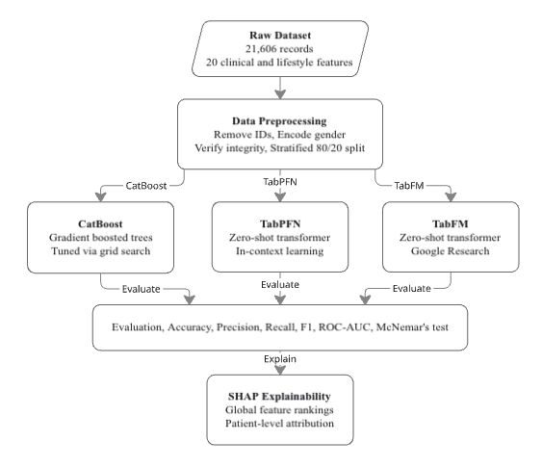
Figure 1: Overall System Architecture Diagram

Raw patient records will first pass through a preprocessing stage that removes non-informative identifier fields, encodes categorical attributes, and prepares the feature set for downstream modeling. The cleaned data will then branch into three independent modeling paths, each corresponding to one of the benchmarked architectures: CatBoost, trained through iterative gradient-boosted decision trees; TabPFN, operating through zero-shot in-context inference; and TabFM, Google's more recently introduced tabular foundation model, which likewise performs zero-shot prediction but through an alternating row-and-column attention mechanism. Each model's predictions will then be passed through a shared evaluation stage, where accuracy, precision, recall, F1-score, and ROC-AUC are computed under a consistent methodology to allow direct comparison across all three approaches. Finally, SHAP will be applied uniformly across all three trained models, producing both global, cohort-level feature importance rankings and individual, patient-level explanations for specific predictions.

3.2 Dataset Description
The dataset used in this study will consist of 21,606 patient records, assembled from two public sources (Dhankour, 2023; Hair Fall Problem Survey Dataset, 2023) and combining demographic attributes, continuous physiological biomarkers, and binary lifestyle and clinical indicators, following the clinical, nutritional and lifestyle risk factors examined in earlier hair loss studies (Anderson & Roberts, 2025; Patel et al., 2025). The target variable, hair fall risk, will be represented as three ordinal severity tiers: Low, Moderate, and High, in line with the multi-class severity formulation of Widowati et al. (2026).

The feature set will be organized into four broad categories:
1. Demographics and Heredity
- age: patient age, in years
- gender: patient sex (Female, Male, Other)
- family_hair_fall_history: binary indicator (0 = No, 1 = Yes) of hereditary predisposition to hair loss

2. Continuous Physiological and Serum Biomarkers
- Nutritional and mineral markers: total_protein (serum total protein, g/dL), iron (serum iron, µg/dL), calcium (serum calcium, mg/dL), vitamin_d (serum 25-hydroxy vitamin D, ng/mL), manganese (whole blood manganese, µg/L)
- Hair and hydration indices: total_keratine and hair_texture, both composite 0–100 scores reflecting hair condition rather than standard clinical laboratory measurements; body_water_content, expressed as a percentage
- Hepatic and stress biomarkers: alt_liver (serum alanine aminotransferase, U/L), stress_level (modeled on the 0–40 Perceived Stress Scale)

3. Clinical and Coexisting Conditions (binary flags: 0 = No, 1 = Yes)
- chronic_illness: presence of a pre-existing systemic medical condition
- anemia: documented iron or hemoglobin deficiency
- stress: self-reported experience of high psychological stress

4. Lifestyle and Environmental Exposures (binary flags: 0 = No, 1 = Yes)
- late_night_sleep: habitual late sleep timing or delayed circadian pattern
- sleep_disturbance: interrupted sleep or insomnia
- water_reason: regular exposure to hard or chemically treated water
- chemical_use: exposure to hair dyes, relaxers, or other chemical hair treatments

The physiological biomarker data will be sourced from a publicly available dataset (Dhankour, 2023), and the demographic and lifestyle indicator data will be sourced from a separate publicly available survey dataset (Hair Fall Problem Survey Dataset, 2023), with respondent names to be removed prior to processing. As the two sources originate from different respondent groups, feature values will be adjusted using domain-informed relationships from dermatological literature to produce the final dataset used in this study (Anderson & Roberts, 2025; Patel et al., 2025; Widowati et al., 2026). Because respondents in the two sources are not the same individuals, the combined dataset is a semi-synthetic benchmark: the adjustment rules will be documented, and the associations learned by the models will be understood to reflect relationships encoded from the literature, not new clinical evidence. This limitation will be stated explicitly when the results are discussed.

3.3 Data Preprocessing
To ensure data integrity and consistent handling across all three modeling architectures, the following preprocessing steps will be applied prior to training:
- Identifier Removal: Non-informative identifier columns (id and full_name) will be removed prior to training, as they carry no predictive value and risk introducing spurious associations if retained.

- Categorical Encoding: The gender attribute will be normalized and mapped into a numeric format (0 = Female, 1 = Male, 2 = Other) to accommodate models requiring numeric input. The target variable, hair_fall, will already be represented as zero-indexed ordinal labels (Y ∈ {0, 1, 2}, corresponding to Low, Moderate, and High risk respectively), requiring no additional transformation.

- Missing Value Handling: The dataset will be verified to contain no missing values across any feature or target column following data cleaning; if any missing values are identified, an appropriate imputation method will be applied prior to model training.
3.4 Model Selection
Rather than relying on traditional baseline classifiers or simple ensemble voting schemes, this study benchmarks three distinct, state-of-the-art tabular modeling paradigms.

3.4.1 State-of-the-Art Categorical Boosting: CatBoost
CatBoost is selected for its specialized handling of heterogeneous tabular data. As a gradient boosting framework, it builds decision trees sequentially, each correcting the residual errors of the previous ensemble, minimizing a regularized objective at iteration t:
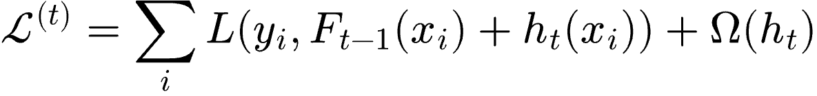

where L(.) is the multi-class cross-entropy loss, F_{t-1} is the prior ensemble, h_{t} is the new tree, and Ω(h_{t}) penalizes complexity to control overfitting. CatBoost mitigates target leakage through Ordered Target Encoding and builds Symmetric (Oblivious) Decision Trees, giving it strong resistance to overfitting on relatively small clinical datasets and making it a robust tuned baseline for this study.
Architecture. The base learner in CatBoost is a symmetric (oblivious) decision tree, in which the same feature-threshold split is applied at every node of a given level, so a tree of depth d has 2^{d} leaves. This regular structure acts as a regularizer and allows fast inference. Trees are added one after another, and ordered boosting computes each training example's gradient from a model that was not fitted on that example, which reduces prediction shift. Categorical features are converted with ordered target statistics. For the three-class task, the ensemble outputs one score per class, and a softmax converts these scores into class probabilities.

3.4.2 Frontier Tabular Foundation Model: TabPFN (v3)
TabPFN is selected as a well-established tabular foundation model that performs zero-shot prediction through in-context learning. Pretrained offline on synthetic datasets generated from structural causal models, it requires no dataset-specific training. At inference, it is given a training context D_{train} and query x_{test} directly, computing the prediction in a single forward pass:

This is implemented via self-attention, computing contextual relationships across features and samples:
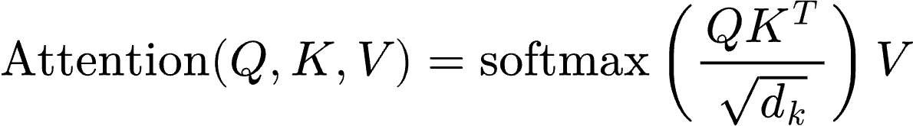

enabling zero-shot inference without hyperparameter tuning or feature scaling.
Architecture. TabPFN is a transformer encoder that receives the labeled training rows and the unlabeled query row as a single input sequence. Each row is embedded as a token, and stacked self-attention layers let the query token attend to the labeled context rows, so the prediction is formed from the training examples most relevant to the query. A classification head on the query token outputs the class probabilities. All weights are fixed after pretraining on synthetic datasets, so no gradient updates occur on the hair fall data.

3.4.3 Zero-Shot Tabular Foundation Model: TabFM
TabFM is selected as a second, independently developed foundation model, allowing comparison between two competing zero-shot architectures rather than just gradient boosting versus one foundation model. Released by Google Research, TabFM alternates row- and column-wise attention over the input table before an in-context transformer produces predictions, distinguishing it from TabPFN's primarily sample-wise attention. Like TabPFN, it requires no training or tuning:

Including TabFM allows this study to test whether zero-shot performance gains generalize across architectures, or are specific to one model's design.
Architecture. TabFM first embeds every cell of the table. Its transformer blocks alternate between column-wise attention, which relates the values of the same feature across rows, and row-wise attention, which relates the features within one row. The resulting row representations are passed to an in-context transformer in which labeled context rows and query rows interact, and a prediction head outputs the class probabilities. As with TabPFN, the weights are fixed after pretraining.

3.5 Experimental Setup and Hyperparameter Tuning
Model configurations will reflect each architecture's nature: a tuned gradient-boosted model versus two zero-shot foundation models requiring no optimization.
- CatBoost Setup: Hyperparameter tuning will use grid search across tree depth (depth ∈ {4, 6, 8}) and learning rate (learning_rate ∈ {0.01, 0.03, 0.1}), with L2-regularized leaf weights and early stopping after 50 rounds. The optimal configuration will be selected via Stratified 5-Fold Cross-Validation on the training partition, based on macro-F1.
- TabPFN Setup: As a pretrained foundation model, TabPFN will require no tuning. Training data will be supplied as context, and predictions generated in a single forward pass.
- TabFM Setup: Consistent with its zero-shot design, TabFM will likewise require no tuning. The training partition will be supplied as context, and predictions generated through its row-and-column attention mechanism.

Unlike CatBoost's extensive grid search, TabPFN and TabFM will require no tuning at all, a deliberate asymmetry central to this study's research question: whether zero-shot foundation models can match a carefully tuned gradient-boosted baseline without comparable optimization effort.

3.6 Explainability Architecture (SHAP Integration)
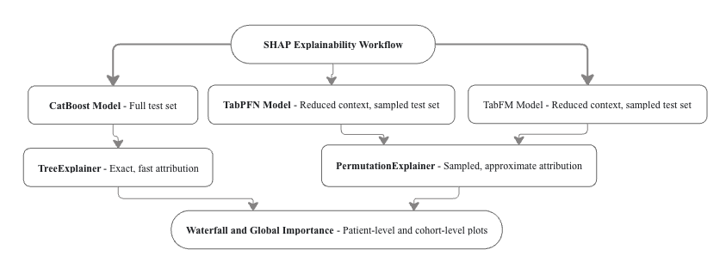
Figure 2: SHAP Explainability Workflow

To address the interpretability limitations common to both boosting and transformer-based architectures, post-hoc explainability will be integrated across all three trained models using Shapley Additive Explanations (SHAP). Grounded in cooperative game theory, SHAP decomposes each model's prediction into additive per-feature contributions:

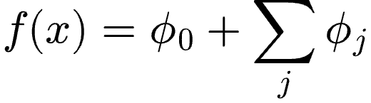

where φ₀ is the baseline expected prediction and φ_{j} quantifies the specific contribution of feature j (for example, iron, stress_level, total_protein, or family_hair_fall_history) to the final predicted risk tier.
For CatBoost, SHAP values will be computed using the TreeExplainer algorithm, which exploits the model's tree structure to compute exact Shapley values efficiently across the full test set. For TabPFN and TabFM, SHAP values will instead be computed using PermutationExplainer, since neither model exposes an internal tree structure that TreeExplainer can exploit. As permutation-based SHAP estimation requires repeated forward passes through each model's full in-context attention mechanism, its computational cost is expected to scale with both context size and the number of samples explained; if this proves computationally prohibitive, TabPFN's and TabFM's SHAP analyses will instead be conducted using a reduced training context and a sampled subset of test instances, rather than the full training set and complete test partition used for TreeExplainer.
Across all three models, this framework will produce both patient-level waterfall plots, showing how individual features shifted a specific prediction away from the baseline, and cohort-level global importance rankings, showing which features most consistently influenced predictions across the dataset as a whole.

3.7 Tools and Technologies
This research will be implemented using the following Python-based software stack:
- Data Manipulation and Preprocessing: Pandas and NumPy for data handling, and Scikit-learn for stratified train-test splitting, Stratified 5-Fold Cross-Validation, and standard evaluation metrics.
- Tabular AI Engines: The official CatBoost framework for gradient-boosted tree training; the TabPFN Python package for zero-shot tabular foundation model inference; and Google Research's TabFM package for the second zero-shot tabular foundation model.
- Explainable AI: The official SHAP library, which will be used to compute both TreeExplainer-based and PermutationExplainer-based feature attributions across all three models.
- Statistical Analysis: Statsmodels, which will be used to compute McNemar's test for pairwise statistical significance testing between model predictions, and Wilson score confidence intervals for reported accuracy figures.

3.8 Experimental Environment
All experiments will be executed within a standardized, cloud-based environment on Google Colab, using the same runtime type for every model so that execution time and latency measurements are comparable. The Python runtime, the GPU model, the available system RAM, and the versions of CatBoost, TabPFN, TabFM, SHAP and Scikit-learn will be recorded at the start of each session and reported in the final thesis. A fixed random seed (42) and one shared stratified train-test split will be used for all three models.
A GPU-accelerated runtime will be used because TabPFN and TabFM depend on it to keep inference times tractable; CatBoost will be run in the same session for consistency.

3.9 Performance Evaluation Metrics
Model performance across the three ordinal risk categories (Low, Moderate, High) will be evaluated using macro-averaged statistical metrics, applied consistently across all three models, alongside computational efficiency indicators.

- Accuracy: Quantifies overall classification accuracy across all three risk tiers:
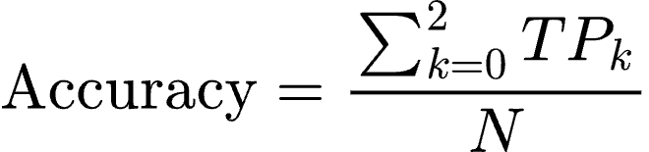

- Macro-Precision: Evaluates prediction fidelity across classes equally, without weighting by class size:
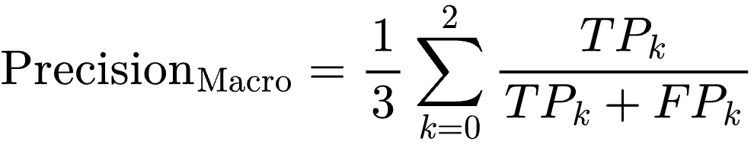

- Macro-Recall: Measures sensitivity across target levels equally:
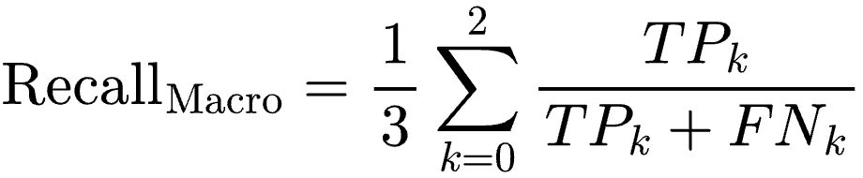

- Macro-F1 Score: Computes the harmonic mean of macro-precision and macro-recall:
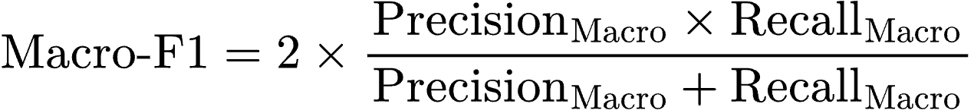

- ROC-AUC: Will be computed using a one-vs-rest strategy across the three risk classes, macro-averaged to summarize discriminative performance independent of class size.
- Computational Latency: Training or context-fitting wall-clock time (seconds) will be measured with Python's time.perf_counter(), from the start of model fitting (CatBoost) or of context loading (TabPFN and TabFM) until the model is ready to predict. Per-sample inference latency (milliseconds/sample) will be calculated as the total time to predict the entire held-out test set divided by the number of test samples, using the same hardware and batch setting for all models. Each timing will be repeated three times after a warm-up run and the mean will be reported. These measurements evaluate deployment feasibility, given that CatBoost's training-then-predict paradigm differs fundamentally from TabPFN's and TabFM's in-context, fit-free inference approach.
- Statistical Significance Testing: Pairwise differences in prediction accuracy between models will be assessed using McNemar's test on the held-out test set, with 95% confidence intervals for each model's accuracy computed via the Wilson score interval method, providing a statistically grounded basis for comparing model performance beyond raw metric values alone.

Chapter 4: Expected Outcome and Working Schedule

4.1 Expected Outcomes
This study aims to determine whether zero-shot tabular foundation models, represented by TabPFN and TabFM, can match the predictive performance of a carefully tuned gradient-boosted baseline, CatBoost, on a multi-tier hair fall risk classification task. The comparison is expected to reveal whether the substantial optimization effort typically invested in gradient boosting yields a measurable advantage over models requiring no dataset-specific tuning.
Beyond raw accuracy, this study anticipates that applying SHAP-based explainability consistently across all three models will provide a transparent, feature-level basis for interpreting predicted risk tiers, helping bridge the gap between predictive performance and clinical interpretability. The overall framework is expected to demonstrate that explainable, data-efficient tabular modeling approaches can offer a viable alternative to traditional gradient boosting for structured health risk prediction tasks.

4.2 Working Schedule
The proposed research will be carried out across a 12-week timeline. Table 1 presents a week-by-week Gantt chart outlining the planned major project milestones.

Table 1: Week-by-Week Project Gantt Chart
Core Activities | W1 | W2 | W3 | W4 | W5 | W6 | W7 | W8 | W9 | W10 | W11 | W12
1. Problem Formulation & Domain Study | ■ | ■
2. Research Objectives & Framework Design |  | ■ | ■
3. Literature Review & Reference Mapping |  |  | ■ | ■
4. Dataset Cleaning & Stratified Preprocessing |  |  |  |  | ▨ | ▨
5.Model Setup (CatBoost & TabPFN v3) |  |  |  |  |  | ▨ | ▨ | ▨
6. Hyperparameter Tuning & In-Context Setup |  |  |  |  |  |  |  | ▨ | ▨
7. Cross-Validation & Model Benchmarking |  |  |  |  |  |  |  |  | ▨ | ▨
8. Explainability (SHAP Integration & Plots) |  |  |  |  |  |  |  |  |  | ▨ | ▨
9. Metrics Evaluation & Performance Analysis |  |  |  |  |  |  |  |  |  |  | ▨ | ▨
10. Final Thesis Documentation & Presentation |  |  |  |  |  |  |  |  |  |  |  | ▨

■ Completed (proposal preparation)
▨ Planned (to be carried out following proposal approval)

References

Anderson, J., & Roberts, M. (2025). Clinical feature analysis and survey-driven lifestyle metrics for predicting hair loss severity. Applied Medical Informatics Review, 18(1), 78–89.
Chen, K., Zhang, L., & Wang, R. (2024). Predicting hair loss with AI: A deep learning framework combining genetic and scalp health data. In Integrating AI, machine learning, and IoT in bioinformatics: Innovations in biotech and medical research (pp. 100–107). CRC Press.
devYRPauli. (2026, July). tabfm-evaluation: Independent 3-machine evaluation of Google TabFM [Computer software]. GitHub. https://github.com/devYRPauli/tabfm-evaluation
Dhankour, B. (2023). Hair loss dataset [Data set]. Kaggle. https://www.kaggle.com/datasets/brijlaldhankour/hair-loss-dataset
Hair fall problem survey dataset (Version 1) [Data set]. (2023). Mendeley Data. https://data.mendeley.com/datasets/g46n66frrh/1
Hollmann, N., Müller, S., Eggensperger, K., & Hutter, F. (2023). TabPFN: A transformer that solves small tabular classification problems in a second. Nature Machine Intelligence, 5(5), 485–496.
Kong, W., & Das, A. (2026, June). Introducing TabFM: A zero-shot foundation model for tabular data. Google Research Blog. https://research.google/blog/introducing-tabfm-a-zero-shot-foundation-model-for-tabular-data/
Lundberg, S. M., & Lee, S.-I. (2017). A unified approach to interpreting model predictions. In Advances in neural information processing systems (Vol. 30, pp. 4765–4774).
Patel, S., Gupta, V., & Mehta, N. (2025). Predictive modeling of hair fall using decision tree and random forest architectures. EAI Endorsed Transactions on Pervasive Health and Technology, 11, e1–e10.
Prokhorenkova, L., Gusev, G., Vorobev, A., Dorogush, A. V., & Gulin, A. (2018). CatBoost: Unbiased boosting with categorical features. In https://research.google/blog/introducing-tabfm-a-zero-shot-foundation-model-for-tabular-data/Advances in neural information processing systems (Vol. 31, pp. 6638–6648).
Sai, C. N. V., Archana, E., Vivek, B., Dhanwanth, B., & V. K. S. (2023). Enhancing hairfall prediction: A comparative analysis of individual algorithms and an ensemble method. International Journal on Recent and Innovation Trends in Computing and Communication, 11(6s), 499–508.
Sayyad, M., & Midhunchakkaravarthy, S. (2023). Machine learning-based diagnostic model for alopecia areata prediction. https://github.com/devYRPauli/tabfm-evaluationJournal of Dermatological Informatics, 15(2), 45–52.
Shakeel, C. S., Khan, S. J., Chaudhry, B., Aijaz, S. F., & Hassan, U. (2021). Classification framework for healthy hairs and alopecia areata: A machine learning (ML) approach. https://www.kaggle.com/datasets/brijlaldhankour/hair-loss-datasetComputational and Mathematical Methods in Medicine, 2021, Article 1102083.
Widowati, A., Yuniarto, S. A., & Syaipullah, M. A. R. (2026). Explainable machine learning decision support system for multi-class hair loss severity classification. https://data.mendeley.com/datasets/g46n66frrh/1International Journal of Technology in Education and Science, 10(1), 115–136.

